Why My Boarding Strategy Is the Best Choice

1.The Other Strategies

1.1 Back-to-Front (Block Boarding)
The idea: Split the plane into a few sections by row number, and board the back section first, then the middle, then the front.
What it assumes: Once you're in the right section, it doesn't matter what order people board in, there won't be conflicts.
The problem: This assumption turns out to be wrong. A famous 2002 study (van Landeghem & Beuselinck) found this method can be slower than just letting people board randomly. A 2025 study (Płanda & Skorupski) also found it falls apart the worst when things go wrong like a late passenger or a jammed scanner.

1.2 Random Boarding
The idea: people just board in whatever order they show up.
What it assumes: Letting people mix naturally actually spreads them out better than forcing them into a strict order.
Supporting research: The same 2002 study, plus a 2008 “statistical mechanics” study that mathematically modelled why random boarding isn't as bad as it sounds.

1.3 Outside-In (WilMA — Window, Middle, Aisle)
The idea: Just board everyone with a window seat first, then everyone in the middle, then everyone on the aisle.
What it assumes: The real slowdown isn't which row someone's in, it's people having to climb over each other at their own row.
Supporting research: America West Airlines proved this worked in real life back in 2005. A 2025 study (Jaehn, Meissner & Neumann) also found this is the best option specifically when passengers are walking quickly.

1.4 Steffen's Method
The idea: Give every single passenger their own exact position in line, calculated so two people never need the same space in the aisle at the same time.
What it assumes: All ~180 passengers will correctly remember and follow their individual, assigned spot in a long line.
The problem: In lab tests, this is the fastest method by far (Steffen, 2008; Steffen & Hotchkiss, 2012). But no airline has ever actually used it, because in real life, people don't remember or follow an individual number in a crowd. It looks great on paper and falls apart at the gate.

1.5 Modified Optimal (Luggage-Aware Steffen)
The idea: Take Steffen's method but also factor in how much carry-on luggage each passenger has and adjust their position accordingly.
What it assumes: Airlines can somehow know in advance exactly how much luggage each passenger is bringing.
Supporting research: Milne & Kelly (2014) and a cellular-automaton simulation study (2014) both explored this, but it inherits the same real-world problem as Steffen's method, it's hard to run at a gate.

2. My Strategy — The Staggered Zone Hybrid
My method splits the cabin into three row-zones — rear (rows 21–30), front (rows 1–10), and middle (rows 11–20) and moves through window, middle, and aisle seats in five stages. The zones don't board as clean, separate blocks; instead, each zone's seat-type call is staggered relative to the others, so no single part of the cabin sits in heavy two-directional foot traffic for the whole process.

The five boarding phases
Phase | Who boards
1 | Window seats, rows 11–30 (rear + middle zone windows together)
2 | Middle seats, rows 21–30 + Window seats, rows 1–10
3 | Middle seats, rows 11–20 + Aisle seats, rows 21–30
4 | Middle seats, rows 1–10 + Aisle seats, rows 11–20
5 | Aisle seats, rows 1–10
Every one of the nine row-zone / seat-type combinations (window, middle, and aisle, across the front, middle, and rear zones) is boarded exactly once, but each zone reaches its window → middle → aisle progression at a different pace: the rear zone moves fastest, the front zone is offset behind it, and the middle zone is spread out the most — its window seats join early (phase 1), but its aisle seats aren't called until phase 4, meaning the middle zone is deliberately the slowest to fully clear. Within any single phase, passengers are not given a strict order relative to each other, which is where the random-boarding element comes in.

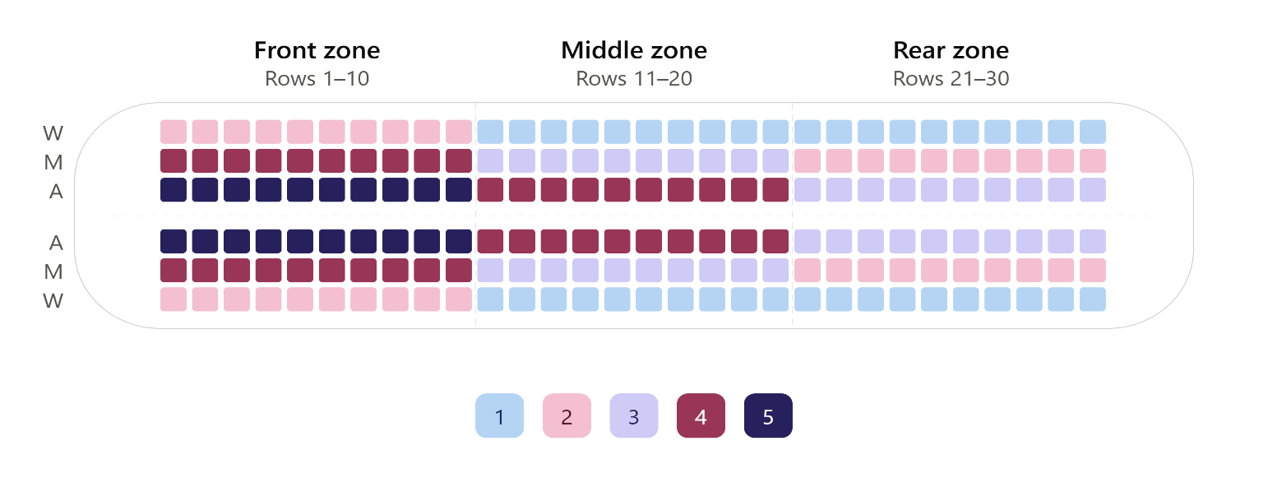

What is this built from
To be precise about where this method comes from, it combines three already-known ingredients rather than being invented from nothing:
- Window-Middle-Aisle (Outside-In): the seat-type order every zone follows over the course of the five phases.
- Random boarding: no enforced order between passengers called within the same phase.
- Reverse Pyramid staggering: the core structural idea of offsetting one section of the cabin's seat-type progression relative to another so no single section clogs the aisle on its own extended here from the classic 2-zone (rear/front) version into a 3-zone, 5-phase version.
The honest way to describe this: the individual ingredients already exist in literature, but this specific 5-phase, 3-zone staggered sequence is not something I found published or tested anywhere. That makes it a novel combination and extension, not a novel invention from scratch.

Why this design might work (the hypothesis, not a guaranteed result)
This is important to say clearly: I do not yet know that this strategy is faster or more efficient than the others. That is exactly what the simulation is going to test. What I do have is a logical reason to expect it might perform well:
- The middle of the cabin normally gets foot traffic from both directions (people walking toward the front and people walking toward the back) for the entire boarding process, in most other strategies.
- By spreading the middle zone's own window → middle → aisle progression across more phases than the outer zones, this design is meant to reduce how concentrated that two-way traffic becomes at any one moment.
- Reverse Pyramid's real airline deployment (America West, 2005) already showed that staggering by seat-type and row-zone together beats plain zone blocking, this method is a logical extension of that same idea to a three-zone, multi-phase structure.
Until the simulation actually runs and produces numbers (mean boarding time, standard deviation, confidence interval, compared against Back-to-Front, Random, Outside-In, Steffen, and Modified Optimal), this stays a hypothesis grounded in existing research, not a proven claim.

Adding a predictive layer (the AI/analytics component)
On top of the rule-based sequence above, the project also adds a lightweight, data-driven layer: after running the simulation many times with different passenger mixes (percentage of heavy-luggage passengers, group travelers, assistance needs, compliance rate), a simple prediction model (linear regression or random forest, following the same approach used by Gehlen & Ronzani, 2025) is trained on the results.
This model does two things:
- Predicts expected boarding time for this specific 5-phase strategy, given a new flight's passenger profile.
- Identifies which passenger factors (luggage, group size, compliance, etc.) most affect this method's performance, something that hasn't been tested for this particular staggered hybrid before.
This keeps the core research method as simulation-based (SimPy, Monte Carlo trials, statistical comparison) while adding a genuinely useful, feasible analytics layer on top without overreaching into a full real-time AI system that the project timeline can't support.

3. Why My Strategy Is Strong
1. It targets both known causes of delay at once. Row congestion (the problem Back-to-Front addresses) and seat-interference (the problem Outside-In addresses) are the two dominant delay sources identified across the literature. This method is built to address both together, phase by phase.
2. It's specifically designed to protect the middle of the cabin. Unlike a plain zone-by-zone or Back-to-Front approach, where the middle section absorbs foot traffic from both directions the entire time, this method deliberately spreads the middle zone's boarding across more phases, so it isn't caught in that two-way congestion all at once.
3. It builds on a strategy with real-world proof, not just simulations. Reverse Pyramid, the strategy this method extends was actually deployed by America West Airlines in 2005 and measurably cut boarding time on full flights. This gives the underlying logic real operational credibility, not just theoretical support.
4. It stays realistic to actually run at a gate. Passengers only need to know two things at any point: their zone and their current seat-type call. That is far simpler to announce and enforce than something like Steffen's method, which requires individually memorized positions and has never been deployed by any airline.
5. It adds a data-driven layer without overreaching. Rather than claiming a fully autonomous AI system, the project adds a modest, feasible predictive model trained on its own simulation data giving a genuine analytics contribution that fits realistically within the project timeline.

Note: This method is a specific, previously untested combination of three known techniques , not a claim of total invention, and not yet a proven winner. The simulation is what will determine whether it actually reduces boarding time compared to Back-to-Front, Random, Outside-In, Steffen, and Modified Optimal. What can be said now, honestly, is that the design has a clear logical basis grounded in real research and one real airline's field results, and that basis is what the simulation is built to test.

